PLANNING YOUR WEDDING

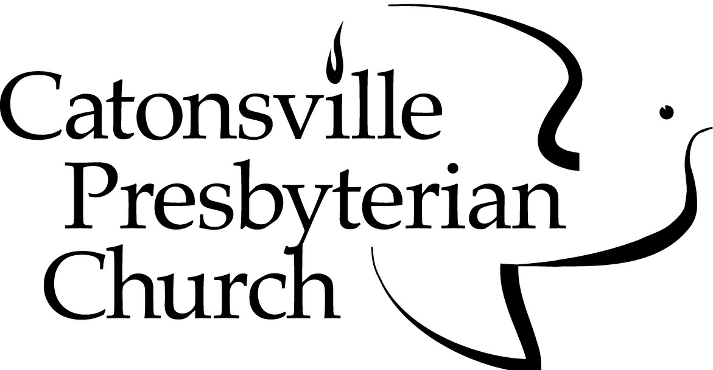

1400 Frederick Road
Catonsville, MD 21228
410-747-6180
www.catonsvillepres.org

Pastors
The Reverend Kenneth E. Kovacs, Ph.D.
The Reverend Dorothy L. Boulton, M.Div.

PLANNING YOUR WEDDING

The staff of the Catonsville Presbyterian Church welcomes the opportunity to share with you in the planning of your marriage service. It is our hope that these guidelines will assist you in your preparation.
Scheduling
It is suggested that you schedule the date of your wedding with the church office at least six months in advance. Weddings are not normally scheduled for Sundays, or during Holy Week, Easter, Christmas Eve, or Christmas Day, as these special times are reserved for other worship events in the life of the congregation.
Officiating
Ordinarily one of the pastors shall officiate at your wedding. If you would like another clergy person to officiate or participate in the marriage service, arrangements shall be made through the officiating pastor, and an invitation will be extended to that person.
The officiating pastor and the Wedding Committee will meet with the wedding party at a scheduled rehearsal to explain procedures. It is important that the rehearsal begin promptly at the appointed time.
The Ceremony
The worship service is led by the officiating pastor who shall be consulted early in the planning about the participation of friends and/or relatives in the service. Special readings or departures from the traditional service must be discussed with the pastor.
Two departures from the traditional service are often requested: (1) a candle-lighting ceremony and (2) Holy Communion. Both are common and acceptable additions.

Wedding Committee
The Wedding Committee assists the families in planning the rehearsal and the wedding. The committee members are accountable to the pastor. One or two committee members are assigned to each wedding. Someone from the committee will contact the bride or groom to discuss the wedding plans and answer questions.
Licensing
The marriage license is to be delivered to the pastor at the time of the rehearsal. Application for the license is made with the Baltimore County Marriage License Bureau: 410-887-2607. After applying, there is a waiting period of 48 hours before obtaining the license. The license is valid for six months after issue. No blood tests are necessary.
Music
Music is an important part of a wedding service and is to be in keeping with the reverence of worship. All music shall be discussed with the music director and/or organist. Ordinarily the church organist shall play the organ. Any other arrangements must be discussed with the pastor.

The organist should be contacted at least three months in advance of the wedding date to discuss the music (and soloist, if desired).

The use of electronic musical equipment in the sanctuary is not allowed.

Decorations
Arrangements for floral decorations are to be made with the florist of choice. Simplicity is suggested, with a minimum of decorations. No more than two floral arrangements shall be in the chancel. A single floral display may be used. Ribbon or simple floral arrangements may be used to mark pews. Sprays may be put on candelabras.
Masking tape may be used if needed, but no nails, thumbtacks, wire, or cellophane tape are to be placed on the furnishings.
The Wedding Party
It is expected that members of the wedding party will refrain from the use of alcoholic beverages prior to both rehearsal and wedding. No alcoholic beverages are to be served or consumed on the church premises, and smoking is not permitted in the building. It is the couple’s responsibility to inform members of the wedding party of these restrictions.
Throwing birdseed, confetti, or rice is not allowed.
Photographers
Photographs may be taken in the narthex prior to the processional, or in the France Room (where the bride and bridal party prepare for the ceremony) or the Music Room (where the groom and best man await the ceremony). They may also be taken in the sanctuary after the wedding.
Because this is a service of worship, no flash photography is allowed in the sanctuary during the service. Non-flash pictures may be taken from locations that will not distract worshipers: these will be discussed in advance with the pastor.
The couple shall share this information with both professional and amateur photographers. If you plan to videotape your wedding service, the location of equipment shall also be approved by the pastor, so that it will not detract from the service.

Fees for Members
When the bride or groom or one of their parents is an active member of the church, the fees listed below apply. For members, there is no specific fee charged by the pastor. Some families do offer a gift of appreciation, but that is not required.
Please bring the following fees to the rehearsal:
Use of the sanctuary no charge
Organist (consultation, rehearsal,
and wedding) - *AGO minimum $350
Soloist (if not provided by the church) **Variable

Fees for Non-Members
When the bride or groom or a parent is not an active member, the following fees apply:
Use of sanctuary, pastor honorarium,
and Wedding Committee fee $1250
Organist (consultation, rehearsal,
and wedding) - *AGO minimum $350
Soloist (if provided by the church) **Variable

A deposit of $200 is due with the application.
The balance is due 30 days prior to the wedding.

- - - - - - - - - - - - - - - - - - - - - - - - - - - - - - - - - - - - - - - - - - - - - - - -

* American Guild of Organists
** Fee will be determined by the soloist.

Bulletins
Bulletins containing the Order of Worship may be prepared in consultation with the officiating pastor. Church members have the option of having the bulletin produced in the church office. If desired, special wedding bulletin covers may be purchased (at the couple’s expense) through the church office. Please see the office manager for options. Some couples prefer to produce the bulletin themselves, without the use of the church’s services. The officiating pastor shall approve the content of the worship bulletin beforehand, whether it is produced in the church office or not.

Counseling
In order to prepare couples for marriage, pre-marital counseling sessions with a licensed professional are required. These sessions will explore mutual expectations, financial planning, communication, and other resources needed to grow and to strengthen the relation-ship. A minimum of four sessions are required and can be arranged directly with the Suburban Crossroads Counseling, located in the church house. Fee options may be discussed directly with the counselor.

May God bless your wedding, and may you be conscious of God's Spirit and presence with you during the service
and in your home.

04/2019

