1400 Frederick Road
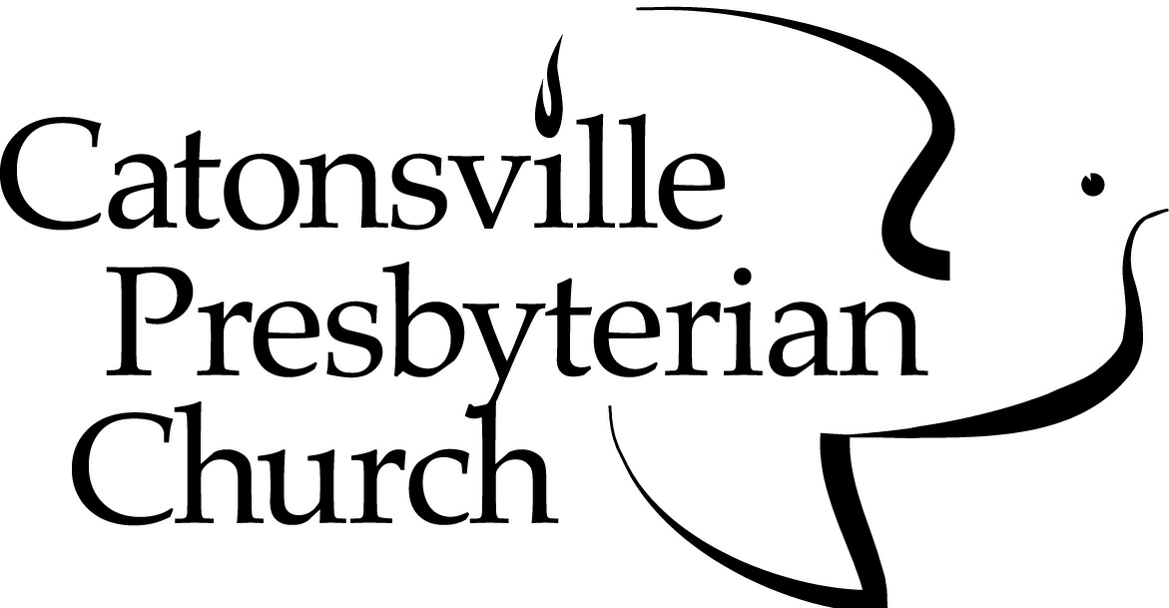
Catonsville, MD 21228
410-747-6180 Fax: 410-747-7263
office@catonsvillepresb.org

WEDDING REQUEST

Wedding Date: Day of the Week: Time:
Rehearsal Date: Day of the Week: Time:

Bride’s Name and Address:

Home Phone: Cell Phone:
Work Phone: Email:
Church Affiliation:
I am presently a member of Catonsville Presbyterian Church.
I am presently a member of church.
If out of state, list city and state: .
I am not a member of a church.

Groom’s Name and Address:

Home Phone: Cell Phone:
Work Phone: Email:
Church Affiliation:
I am presently a member of Catonsville Presbyterian Church.
I am presently a member of church.
If out of state, list city and state: .
I am not a member of a church.

Are you attending worship services at Catonsville Presbyterian Church?
Bride: Yes No Groom: Yes No

Are you interested in uniting in membership with Catonsville Presbyterian Church (CPC)?
Bride: Yes No I am a member Groom: Yes No I am a member
I am exploring membership at CPC I am exploring membership at CPC

Officiating Clergy:
We are requesting that a minister of Catonsville Presbyterian Church officiate at the ceremony:
Rev. Dr. Kenneth E. Kovacs Rev. Dorothy Boulton

We are requesting that the following person co-officiate with a minister of Catonsville Presbyterian Church:
Name:
Church:
Phone(s):

Reason(s) for requesting the wedding at Catonsville Presbyterian Church:

Signature of bride and/or groom:

THIS REQUEST WILL BE PRESENTED TO THE SESSION OF THE
CATONSVILLE PRESBYTERIAN CHURCH FOR APPROVAL.
The Session usually meets on the first Wednesday of the month.
You will be notified of their decision.
(8/17)

